The Path of St. James (Santiago)

- What
In October 2005, I rode my bike across part of Leon and Galicia in northern Spain. The experience was like no other, and I felt it fitting to share this experience with friends, family, and an occasional stranger who visits this site. This site, in fact, is driven by a desire to inspire others to also pursue El Camino.

Since many of the details of the trip are covered in other websites captured in my bibliography, I am pursuing a more biographical take on a bike tour to Santiago. I’d love to hear from others who I know and don’t know and answer any questions or read any comments.

Finally, a word of thanks must go to the following who helped organize this trip:
Katherine Bliss
Sherri Shaffer
Andre ?????
Lauri Wayne
Martin
Kim

- Why
For as long as I could remember, biking across El Camino has been a desire of mine. I’m not sure what every compelled me, but a simple need to have an adventure mixed in with something spiritual I’m sure had a big role. In the end, there were many reasons:
- Spiritual. I must say that sitting in front of a desk is not my idea of a spiritual experience
- Personal. I felt a pilgrimage would be a good way to reflect on a recent Habitat project in Portugal, which I found profoundly rewarding and one way I could give back to others given that I was very fortunate
- Emotional
- Psychological
- Physical
- Patriotic. I wanted to show others that Americans are lovers of other cultures, and they are eager to understand other cultures.

- How
Much to my surprise, I discovered that there were in fact many Caminos to Santiago, and the Camino Frances was just but one of them. Although there was a Camino Portugues that ran right through Braga, Portugal, where I was volunteering for a Habitat Project, I decided to stick to my guns and ride west across northern Spain using El Camino Frances.

- A Bicycle. The first thing required for anyone cycling across Spain is a bike. I first thought that I’d bring a bicycle from the US, but since my beloved Cannondale had been stolen a couple months prior to my trip, this really wasn’t an option. Katherine helped me cope with this loss as did Laurie who lent an empathetic ear, and rightfully noted that is was a “violation”. I couldn’t have put it better myself. No matter, since I later realized that shipping a bicycle to Europe is wrought with risks and my airlines (UA) charged over $100 for this (or free if I only had one check-in), plus it has to be properly packaged to ensure that it arrives safe and sound, but I was told that cyclists can often recycle boxes from bike shops and avoid buying a pricey “bike suitcase”.

Whatever the case, I ultimately decided to rent from a bike company that rents and ships all over Iberia:

www.bikeiberia.com

Overall, I would rate their service as good, and my bike came as expected (even earlier), but I had some problems with the drive train, which I later fixed, early on in the trip. They also rent bike panniers (and a fanny pack with plastic map case), and a bike rental includes:
- Bike helmet
- Cable and lock
- Water bottle
- Repair kit: for flat tires and allen wrenches
- Phone Card. To call your mother and girlfriend!
Laurie provided me with this and other valuable information before my trip. Once ready with a bike, three things were necessary:

- transportation to the head
  - Travel from Portugal to Spain. Check with your local bus station since the train networks appear to be poorly integrated between Spain and Portugal. I found a company with a bus from Braga to Vigo, although they did give me a hard time about taking my bike. Finally, it’s very difficult, I found, to find information about traveling between countries either because it wasn’t consolidated in any website or because tourist offices claimed responsibility for information for travel only within their country. One lady in Braga, Portugal told me that she couldn’t help me with getting to Spain because it wasn’t’ Portugal. I wonder if the EU funds her office?
  - Travel within Spain. To travel from anywhere within Spain (e.g., Vigo to Ponferrada). I recommend
- www.alsa.es
- www.renfe.es
  - Travel within Portugal
- www.cp.pt
- www.renex.com

- misc travel gear
  - The following website has an excellent table of things to take. As advised, travel as light as possible:
- http://home.highertech.net/~belle/camino/info.htm#pack

  - Missing from this list:
- chain tool (depending on how risk averse you are)
- sleeping bag in case you don’t like to use the sheets and blankets provided at the Hospedajes or Hostals along the way(some are allergic)
- snacks, powerbars in case you get hungry along the way
- Medicines or muscle cream. I had a cold, so this was necessary, but some Ben-Gay is always a good thing on this kind of tour
  - Before embarking on Santiago, I recommend that you stop by El Corte Ingles to buy any last minute things. Most big Spanish cities have a store, and their bike supplies are excellent, plus they are open late on the weekends, even on Saturday!
- http://www.elcorteingles.es/deportes/asp/buscador/buscaresul.asp?opcionGuia=DEP&textoGuia=bicicletas&dir=elcorteingles.es&txtNombre=&guiafacil=&texto_seek=&frmtextoBuscado=&frmtextfieldName=&txtLiteral=bicicletas&txt_clave=&lb_famil=&PageSize=15&litBusc=&palabraClave=&search=&CodigoClave=&OPERATIVA=&txtBuscar=&textoBuscado=&textfieldName=&txtNombreGet=

- Maps and Hotel Information
  - Maps. By far, the best maps (including topographical information) are in Jose Maria Anguita Jaen’s “The Road to Santiago: The Pilgrim’s Practical Guide”. The English version appeared to be widely available in Spanish bookstores, but I could only find the Spanish edition on the web:
- http://www.agapea.com/EL-CAMINO-DE-SANTIAGO-GUiA-PRaCTICA-DEL-PEREGRINO--n25847i.htm
- http://www.casadellibro.com/secciones/seccion/0,,75,00.html
  - Hotels, Hospedajes, and Hostels. These are listed in order of their level of luxury. Expect to share everything (except the bed) in a Hostel, whereas a Hotel has many amenities and creature comforts we are used to, sometimes even Internet. Of course, the costs of these options vary from high to low in lockstep with their level of luxury. An excellent source for Hotel Information is the Michelin guide available at just about any bookstore in Iberia. I traveled in the off-season, so making reservation was not necessary. Those traveling in the summer should consider making reservations especially in tourist spots, such as Santiago de Compostela.

- Day 0: Sat. October 1, 2005. Braga, Portugal→Vigo, Spain
  - Since Sept 15, I had been living in Braga, volunteering with Habitat International, an amazing experience in its own right
  - Laurie recommended that I christen any bicycle that would go that far with me, so Rocinante seemed the obvious choice, since in some ways, this trip was quixotic
  - I received the bicycle earlier than anticipated and had a photo taken with me, Rocinante, Kim, and Sherri

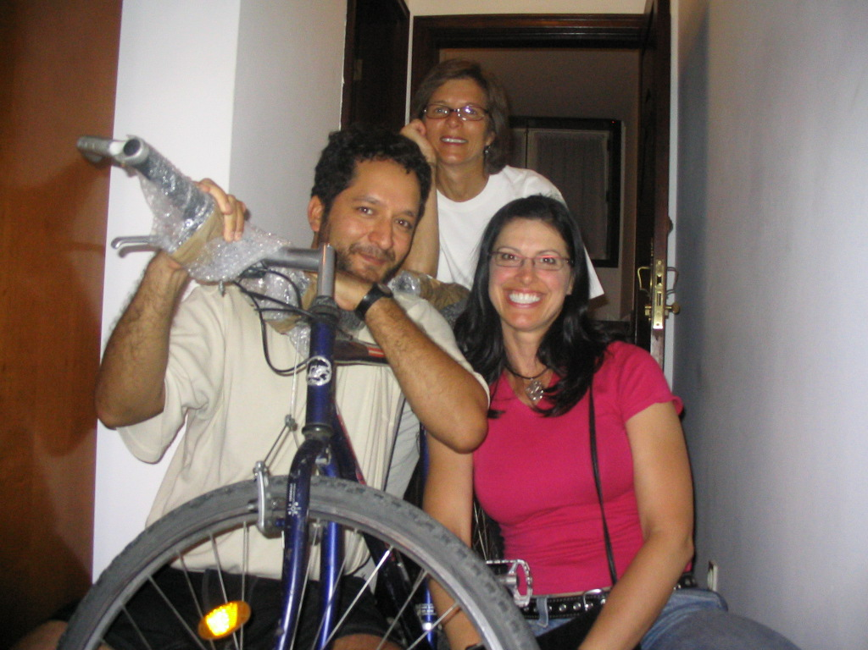

  - Later in the day, I left for Vigo by bus. Lucky for me, I met some Spaniards who had just finished a tour through central Spain, and heavy smokers, I might add. Impressive. Together we rode to the train station in Vigo, where I had a train to catch early the next morning. En route, my train broke in half, so this was something that I would have to take care of at some point on a Saturday night!
  - The Spaniards and I departed since it appeared as if there was an early train to Ponferrada that night, but I only realized that this information was the result of a misunderstanding between me and the train office. Whatever the case, I was left to fend for myself and El Camino had taken a back seat to the chain that now existed in a plastic bag
  - The first thing I asked after checking into my hotel in Vigo was not for a Bible, or a vodka, or a morning wake up call, but a chain tool, or any tool, for that matter, that would allow me to piece my chain together. The hotel manager’s toolbox had nothing, but I thanked her for trying. Then, I asked her what options were available to me having been warned by the Spaniards that there is NO BIKE STORE open on Sat. night in Spain
  - She then contemplated and responded, “El Cortes Ingles”. Of course, but would this department store have such an esoteric tool? She then called her son, Ivan, who eagerly accompanied me to “El Cortes Ingles” since this was his chance to practice some English
  - He seemed well prepared in the finer point of English language, but if truth be told, I was suffering the pangs of a bad cold that I had acquired (putatively) from one of my Habitat teammates back in Braga, so I wasn’t very coherent. The only thing on my mind was fixing the bike and then getting some rest.
  - So, Ivan and I started on our quest. Much to my surprise, El Cortes Ingles had everything I could ever want for my bicycle, except a brand new chain, which actually turned out to be a good thing. A good thing? Yes, because as I later found out, a new chain can reek havoc on your drive train unless the freewheel is also brand new. Apparently, these two components in a drive train must wear down simultaneously
  - After a trip to El Corte, and then a Pharmacy, in a state of delirium, Ivan and I walked back to the Hotel. I thanked him, enjoyed a Galician meal prepared by his mother, and took my medicine to contain my cold and runny nose. He also informed me, after our many English lessons, that he had never seen a dollar bill, so I promptly took down his mailing address, and promised to send him a buck, so that he could see for himself. He was surprised to hear that dollars were green, and he vowed to one day visit England or the US to improve his English. I hope that he follows in that pursuit
  - I tried calling Katherine that night, but I didn’t have enough change to say anything more than a couple of things, and the conversation ended in an ominous: “I had a few more setbacks on my bike trip”
  - It really wasn’t so bad, and certainly anything I couldn’t handle, but my cold coupled with all the excitement of the trip, had me blurting out thoughts randomly. An over concern of every single detail of what’s next, I believe, is a knee jerk response to just about any future event, a behavior that’s well inculcated in the US, especially by those transactional managers in US business. You know who you are! Seems like that cold is coming back, so I’ll stop there!

- Day 1: Vigo→Ponferrada/ToralDe Los Vados/Villafranca
  - The hotel phone rang loudly. I got up from bed quickly and didn’t even bother to shower. Ivan had helped me take all of my things the day before, so moving everything back downstairs, from the 4th floor, would, I thought, be a problem. But, it was a cinch.
  - Maria ????, at the front desk, had been up all night taking care of the lobby, and she recognized me as I said good-bye and prepared to check out.
  - At 6p.m. the night life or movida was impressive. Young adults hooking up, flirting, socializing…it was great!
  - The train station was just across the street from the hotel. I caught the my train without a problem, and left it in the entrance of the boxcar. Having had my Cannondale stolen back in the US, I then realized that it’d be better stored in the seat in front of me. This was I’m sure much to the consternation of the box car conductor who earlier advised me to keep the bike in the box car entrance.
  - Towards Leon, I asked the train conductor where I could find El Camino, or a good starting point. Because of my cold, I decided to get off one stop before Ponferrada, which was Toral De Los Vados.
  - Ponferrada is the 200K mark for cyclists; it’s the starting point for those wanting to complete the Pilgrimage. I like to reason that even though I may have not started at Ponferrada, I was close enough, plus any difference in miles, I’m sure that I acquired by getting lost.
  - Once in TDLV, I fixed my chain. The Sunday market teemed with vendors and people, but only after 10 am roughly. This gave me some time to enjoy breakfast and to organize things a bit and to determine the way to the head of the trail
  - An old man warned me about the dangers of travel in Leon and his warnings seemed ominous.
  - The first time I fixed my chain, I realized that it had been “threaded” through the derailleur incorrectly, so I had to push a pin out once again and to start from scratch
  - The second I carefully threaded the chain through the derailleur but I had a very difficult time getting the pin through. So tough, in fact, that I had to ask a gypsy man for help. He held the pin while, much to my annoyance, his two kids played and rummaged through my panniers. Why?
  - After having pushed the pin with a chain tool, the gypsy man asked me for 10 Euros. I gave him 5 and told him that I might consider buying something from him especially since he complained bitterly that his daily sales weren’t going so well and that he had mouths to feed
  - I browsed through his kiosk, but found nothing, plus I didn’t want to carry any additional weight. He wouldn’t take no for an answer, so rather than confront him further about it, I told him that I might be interested in a sweater, but I need to find an ATM. I headed straight for an ATM and continued towards the head of the trail without ever turning back
  - The head of the trail was Villafrance de los Bierzo, and riding towards VillaFranc I asked many people for directions: grape pickers, an old Spainard who appeared to have a great amount of respect by those around him. Someday I expect to be like that Spainard: respected by many. The directions, I believe, prevented me from getting lost on more than one occasion. One of the most interesting characters was a young lady and her grandmother, who apparently suffered from Alzhimer’s or some other disease that appeared to affect her wits. As the young lady gave me directions, her mother kept on mumbling or shouting something to the effect of “Where are we going today?” She said this repeatedly. The young lady wasn’t very confident in her directions so I just moved onward
  - In these moments leading to VillaFrance I remember the bright Spanish sun, and dry, arid landscape. I felt dizzy and one of those bouts of anxiety struck me unexpectedly. Why? I can’t explain but I’m slowly beginning to understand that it has to do with a fear that I haven’t identified. My reaction is a fight-or-flight response of some kind, but it seems to be very subconscious. If it is a fight-or-flight response, what is the danger? Is the danger death? Failure?
  - Villafranca is considered one of the more beautiful places on El Camino, and it marks the end of El Camino in Leon and the beginning of El Camino in Galicia. I arrived in Villafranca expecting to stay just a little while and continue all the way to OCebreiro, as suggested in an itinerary that I found on the Internet. Instead, I recovered from an leg injury and tried to wisk away my cold. So, the first stop was naturally the pharmacy
  - Noelia was the pharmacist there and I enjoyed talking to her about the trail, and she knew the area very well since she had lived there her entire life, with very few trips outside of Spain. She didn’t have Internet so I never got her email, but she gave mer her address:
Noelia
Plaza Mayor #7
Villafranca del Bierzo
Leon, Espana

I’d love to write to her to let her know the trip went really well, and see if she ever gets my letter.
  - Realizing that my cold wasn’t getting any better and wanting to rest, I decided to stay the night in Villafranca. Plus, it was a charming town and I also met a fellow traveler on bike from Santa Catarina, Brazil. Her name was Lu and I followed her to a hotel where they had a room available for me. There were, in fact, plenty of rooms for me and Lu. I showered, left for stroll, ate, and returned in time for my first full day on El Camino

- Day 2: Villafranca→Triacastelas
  - Adsfadsfasdfdas

Bibliography

Biking El Camino
http://home.highertech.net/~belle/camino/info.htm Excellent Resource
http://pjnet.org/weblogs/bikethecamino/ Very good Tour Information
http://www.experienceplus.com/bicycling/caminetto.html
http://www.hookedoncycling.co.uk/Off_Road_Holidays/Camino_de_Santiago_-_PIlgrim_R/camino_de_santiago_-_pilgrim_r.html
http://www.easyridertours.com/camino_index.html
http://www.great-explorations.com/Pages/s_santiago.html
http://www.bikesfortheworld.org/

General Info about El Camino
http://www.csj.org.uk/compostela.htm
http://www.archicompostela.org/Peregrinos/Inglés/La%20Compostela%20.htm
http://plaza.ufl.edu/antonini/
http://www.caminoasantiago.com/pagina.php?id=1066

Prayers
http://www.starharbor.com/santiago/devotions.html
http://www.kensmen.com/catholic/pilgrimage.html
http://www.caminhodesantiago.com/index3.htm

